RCBldGH User Manual

1. Introduction
RCBldGH is a parametric building energy consumption and heating/cooling load simulation plugin developed based on the Rhino and Grasshopper API. It automates the processing of 3D building geometries in Rhino and invokes the grey-box RC building energy simulation tool RCBldEng (written in Python) to output energy consumption and heating/cooling load results for building designs.
The toolkit includes the following components:
Parent_Directory/
├── RCBldEng/
│ └── RCBldEng.exe (grey-box RC simulation engine)
├── Projects/ (stores energy simulation results)
├── example.gh (example file)
├── RCBldGH.gha (GH plugin)
├── RCBldGH Manual.docx (user manual)
2. Pre-Setup
2.1 Configure Environment Variables
Add RCBldEng to your system environment variables:
- Variable Name: RCBldEng
- Variable Value: File path to the RCBldEng folder.

2.2 Install the RCBldGH Plugin
Place RCBldGH.gha into Grasshopper’s third-party plugin library folder.
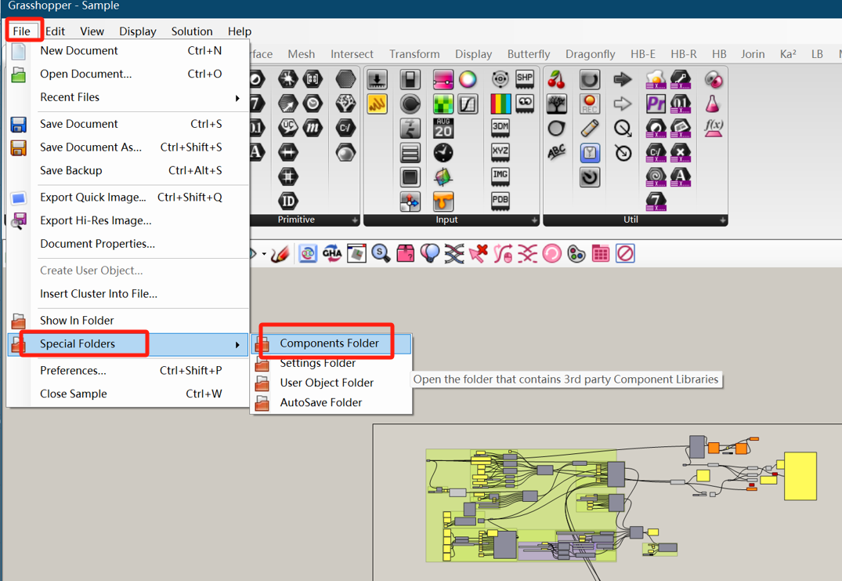

3. Workflow Overview
This section uses the example.gh file to demonstrate the energy simulation workflow.
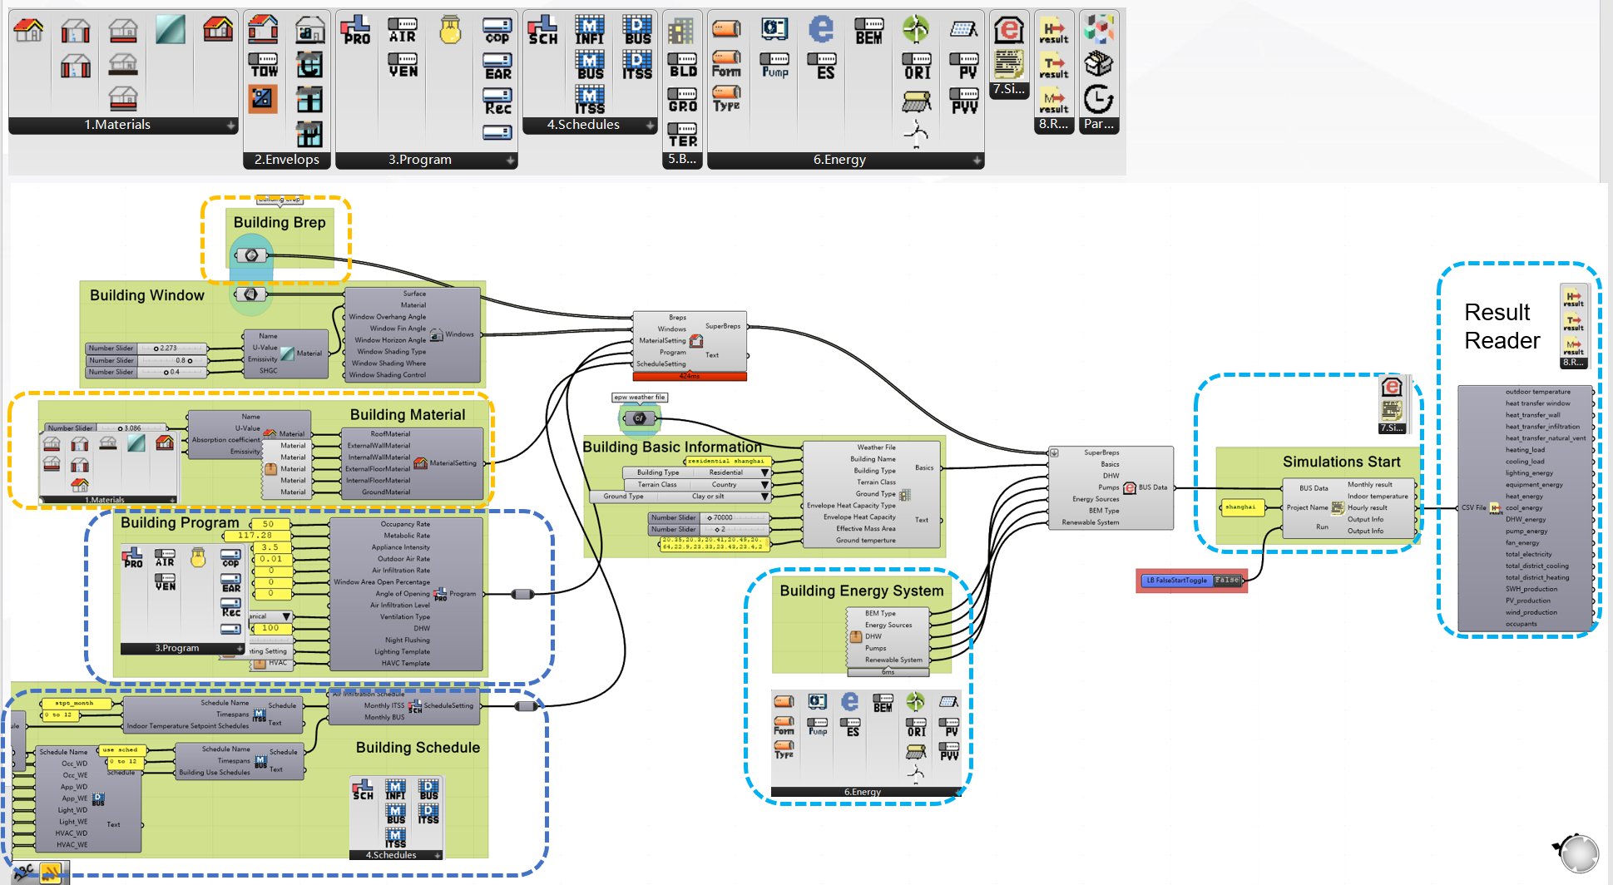
Overview of simulation processes
3.1 Input Data Section
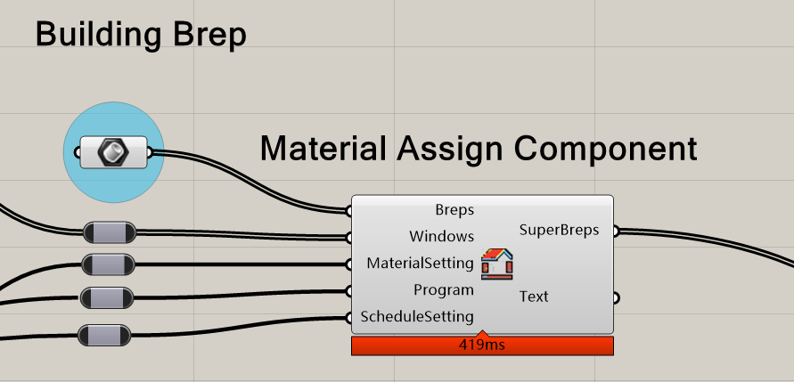
Data input required by the MaterialAssign Component.
3.1.1 MaterialAssign Component
This component aggregates basic information for thermal zones, including:
- Building Geometry: Breps.
- Window Configurations (Windows):
  - Custom window shapes (Surfaces).
  - Window material properties: thermal resistance, emissivity, and solar heat gain coefficient (SHGC).
  - Shading settings: tilt angle, type, location, and control method.
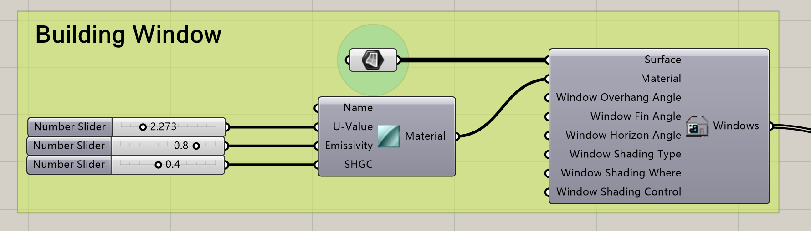
Window Component.
- Envelope Material Settings (MaterialSetting):
  - Roof, exterior walls, interior walls, exterior floor, interior floor, ground, and window glass materials.
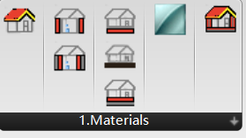
  - Material properties defined by U-value, absorption coefficient, and reflection coefficient.
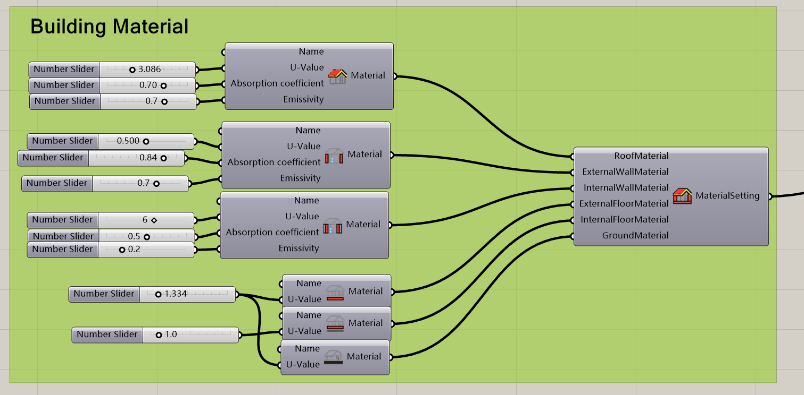
MaterialSetting Component.
- Building Usage (Program):
  - Occupancy rate, metabolic rate, appliance intensity, outdoor air rate, air infiltration rate, window open area percentage, air infiltration level, ventilation type, domestic hot water (DHW) load, night flushing, lighting template, and HVAC template.
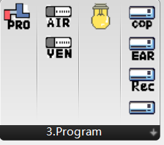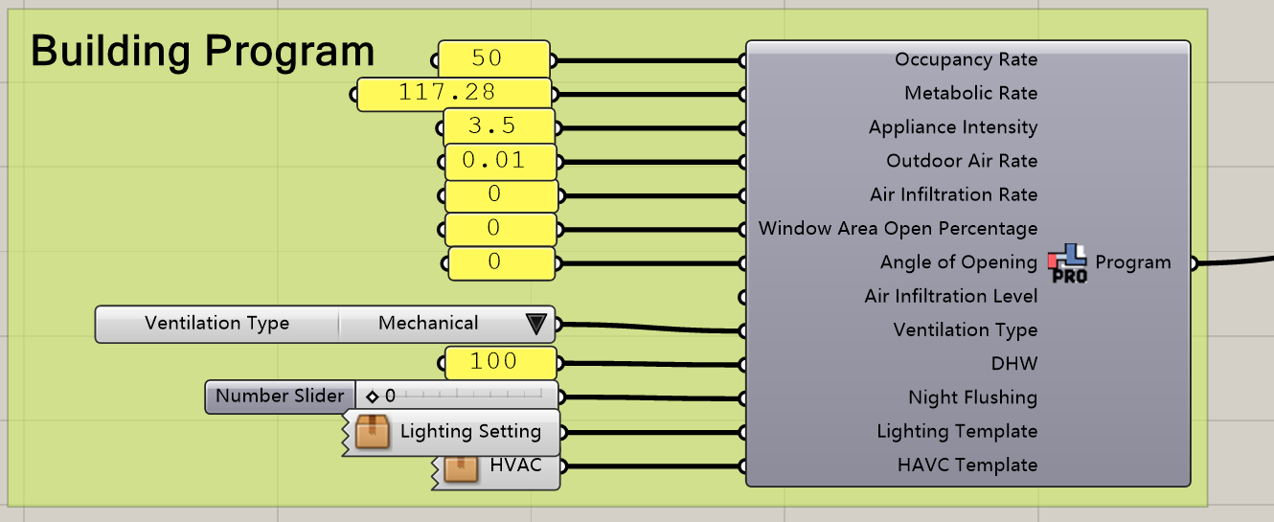
Program Component
- Schedules:
  - 24-hour schedules for heating/cooling, HVAC, lighting, occupancy, and appliance usage, aggregated into weekly schedules via Building Use Schedule (BUS) and Indoor Temperature Setpoint Schedule (ITSS).
  - Monthly schedules (e.g., Monthly BUS, Monthly ITSS, Infiltration Monthly Schedule) combined with Timespans (defining month ranges) to generate annual schedules in ScheduleSetting.
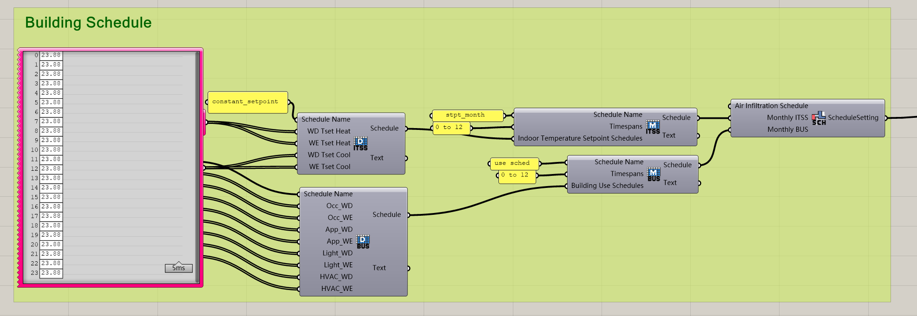
Schedule Component
The MaterialAssign component outputs SuperBreps, which automatically assign material data to building geometries, resolve adjacency relationships, and generate thermal zone data for energy simulation.
3.1.2 BEM Component
This component integrates thermal zone data with:
- Site Information:
  - EPW-format weather file, building name (for labeling), building type, terrain class, ground type, envelope heat capacity, effective mass area, and monthly ground temperatures.
- Energy Systems:
  - Hot water, heat pumps, energy sources, control strategies, and renewable energy types.
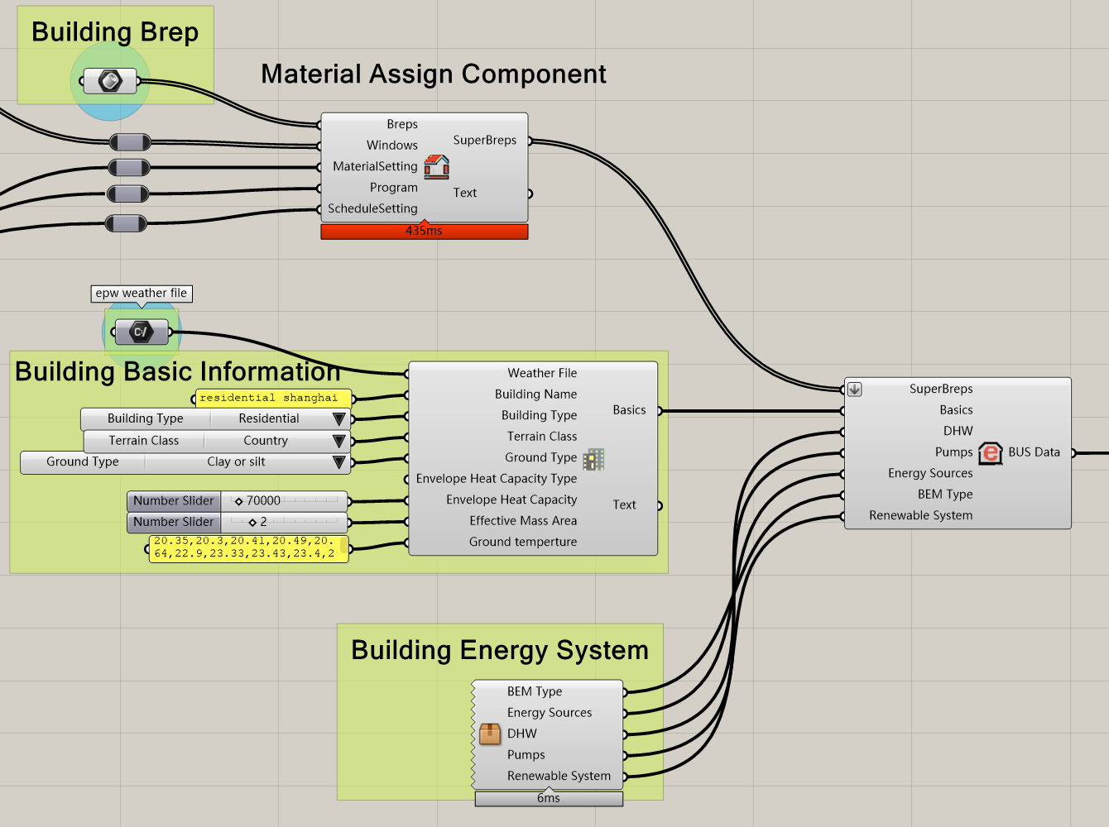
Data input required by the BEM Component.

3.2 Simulation & Results
After completing all inputs, use the Run component to start the simulation by setting Toggle to True. The plugin invokes RCBldEng.exe (via the RCBldEng system variable) to execute the simulation and outputs results as CSV files to the Projects folder.
Result Visualization
- Hourly CSV Reader: Displays hourly energy consumption data.
- Indoor Temperature CSV Reader: Shows indoor temperature results.
- Monthly CSV Reader: Aggregates monthly energy usage.
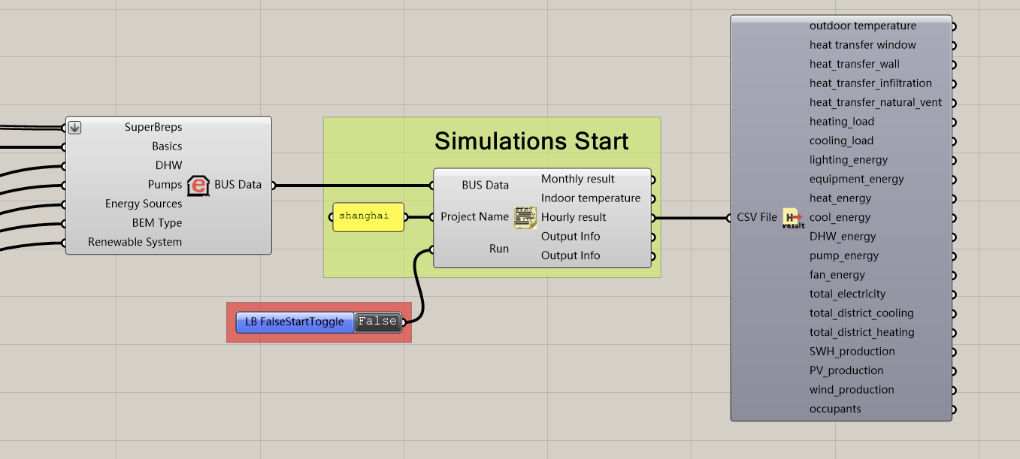
Operation of energy consumption simulation and presentation of results

Note
Ensure Rhino’s model units are set to meters (m). A yellow warning will appear if units are incorrect.

This concludes the plugin workflow guide. Enjoy using RCBldGH!

